***Hackathon Day 5:***

**Functionality testing:**

**Search bar:**

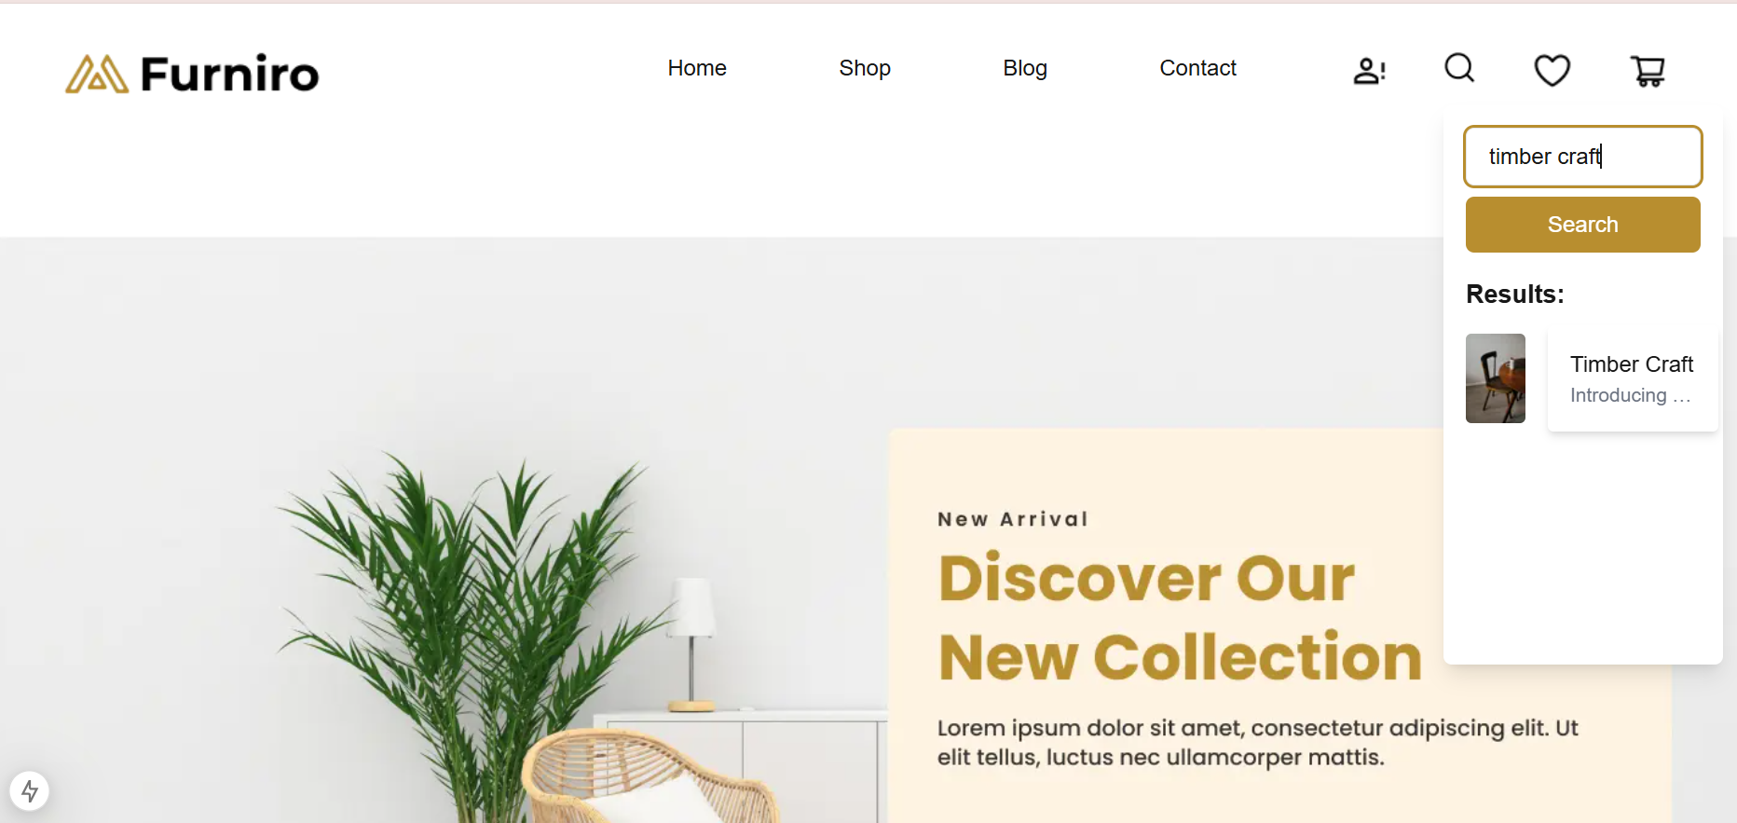

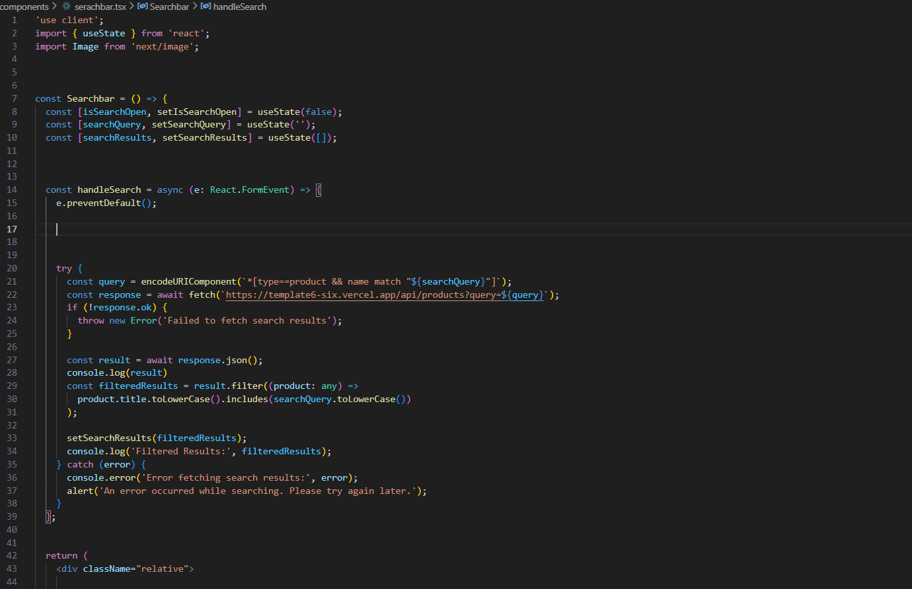

**SignUp/Login**

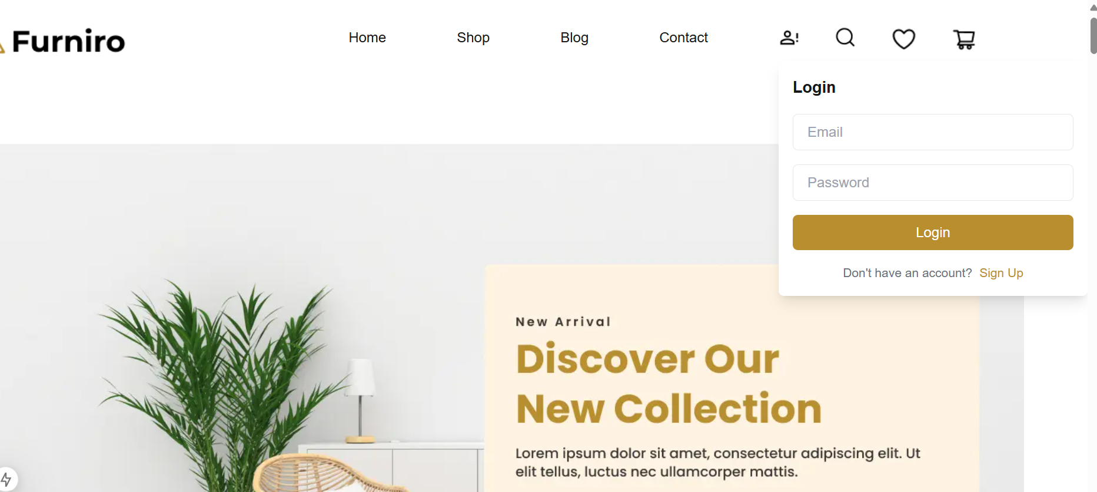

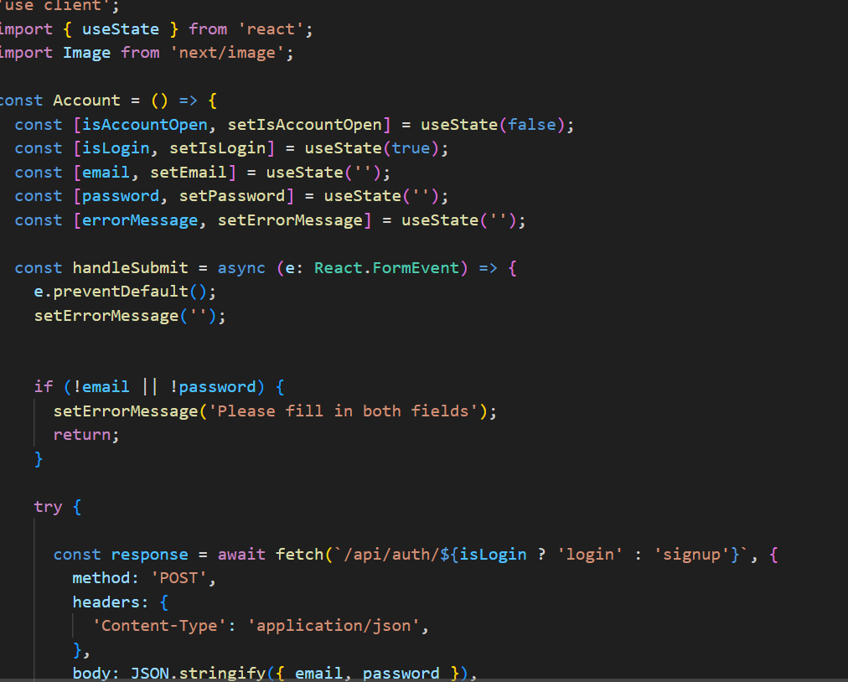

**Add To Cart**

**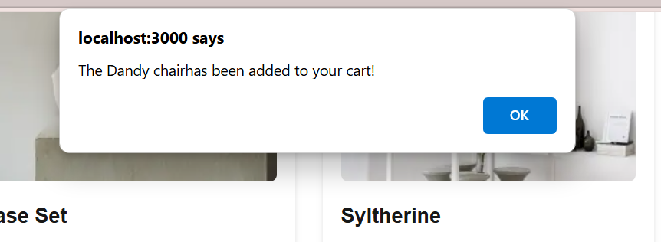  
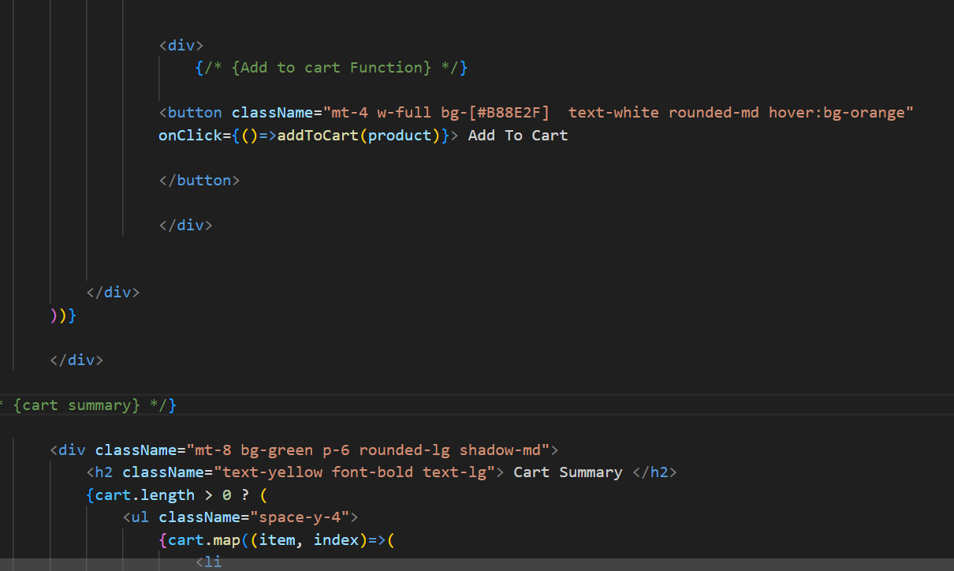**

**Step 3:**

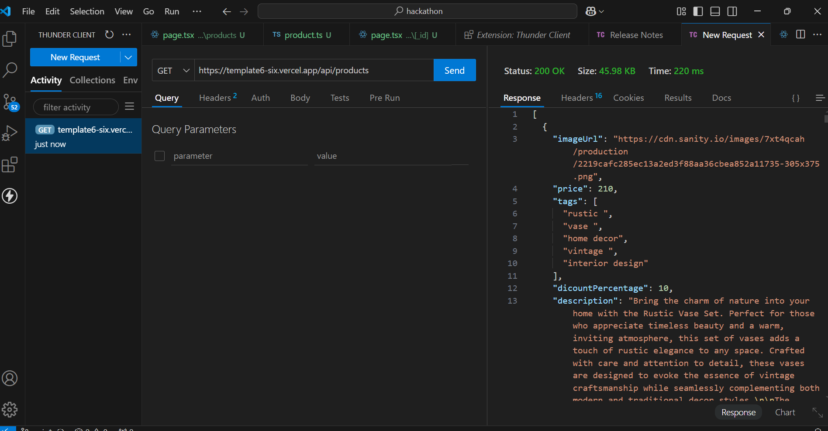

|  |  |  |  |  |  |  |  |  |
| --- | --- | --- | --- | --- | --- | --- | --- | --- |
| Test Case ID | Test Case Description | Test Steps | Expected Result | Actual Result | Status | Severity Level | Assigned To | Remarks |
| 2 | TC001 | Validate product listing page | Open product page > Verify products | Products displayed correctly | Products displayed correctly | Passed | Low | - | No issues found |
| 3 | TC002 | Test API error handling | Disconnect API > Refresh page | Show fallback UI with error message | Error message shown | Passed | Medium | - | Handled gracefully |
| 4 | TC003 | Check cart functionality | Add product to cart > Verify cart contents | Cart updates with added product | Cart updates as expected | Passed | High | - | No issues found |
| 5 | TC004 | Ensure responsiveness on mobile | Resize browser window > Check layout | Layout adjusts properly to screen size | Responsive layout working as intended | Passed | Medium | - | Handle correctly |

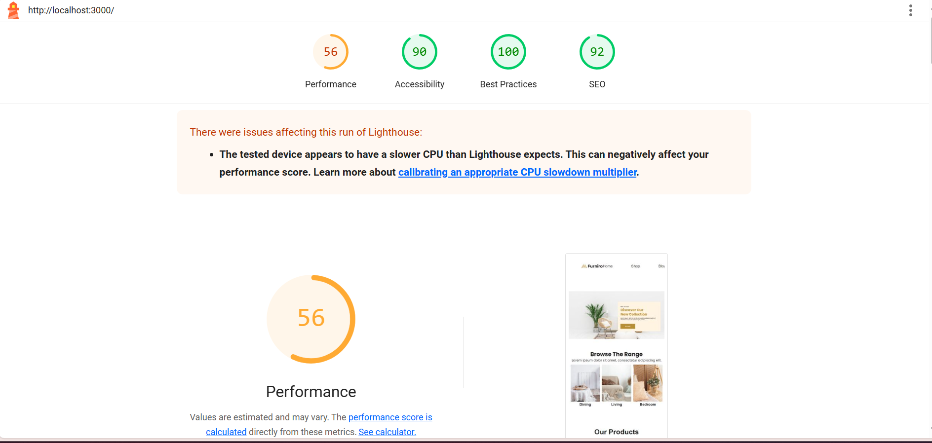

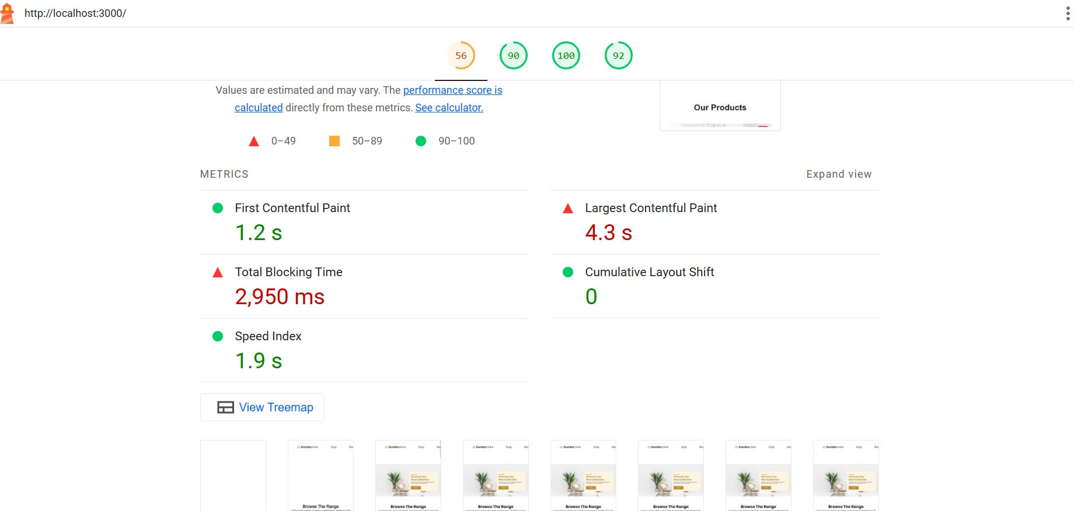

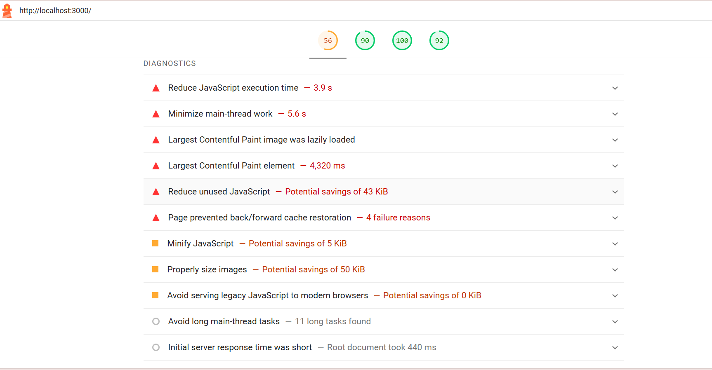

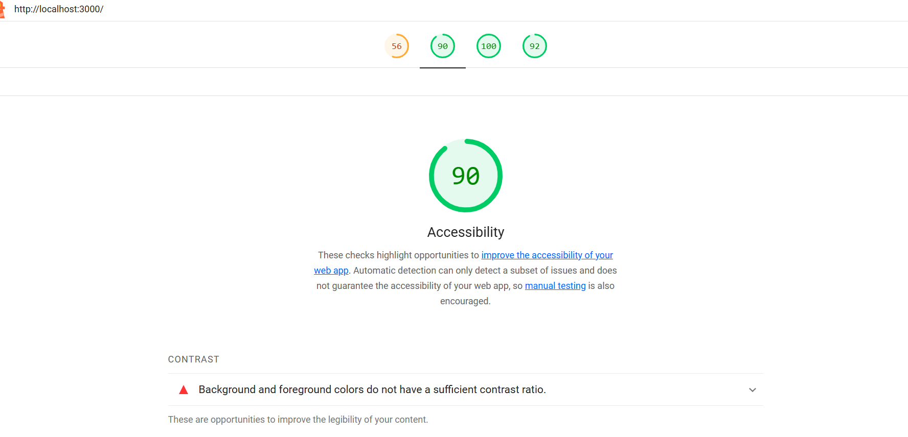

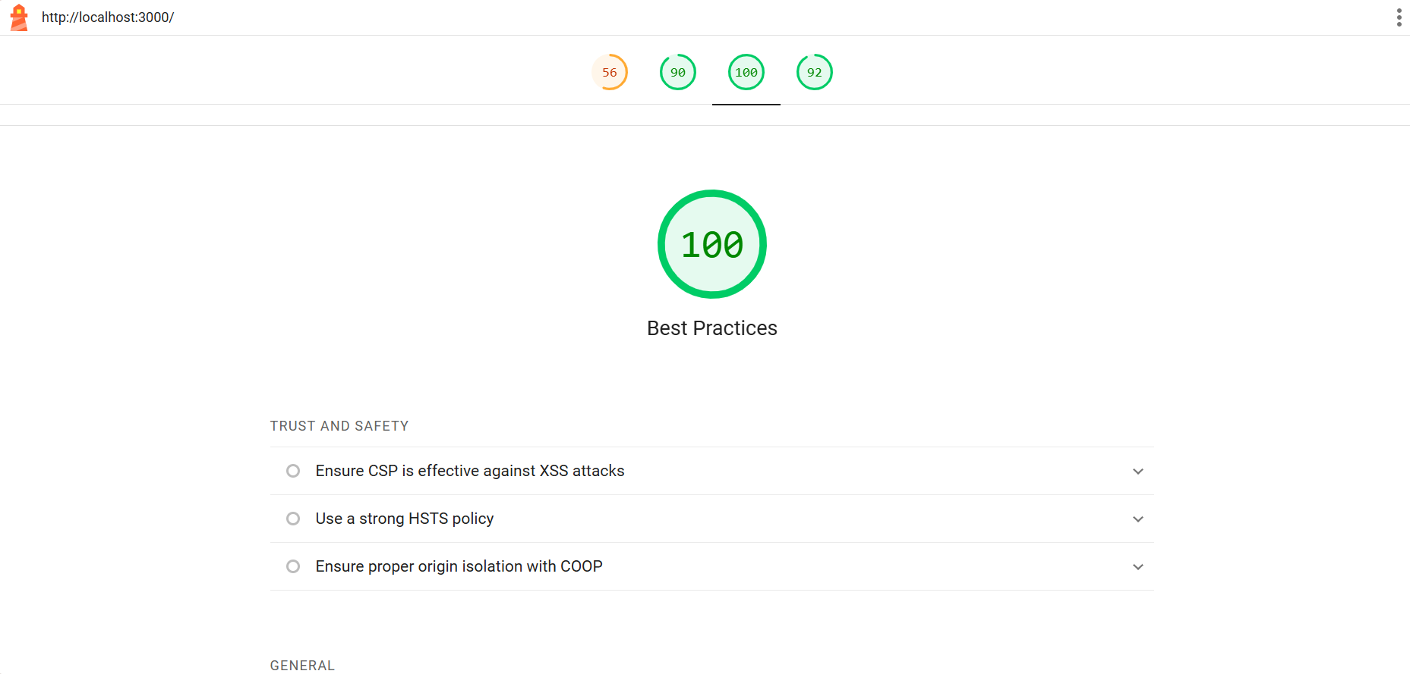

**Performance monitor**

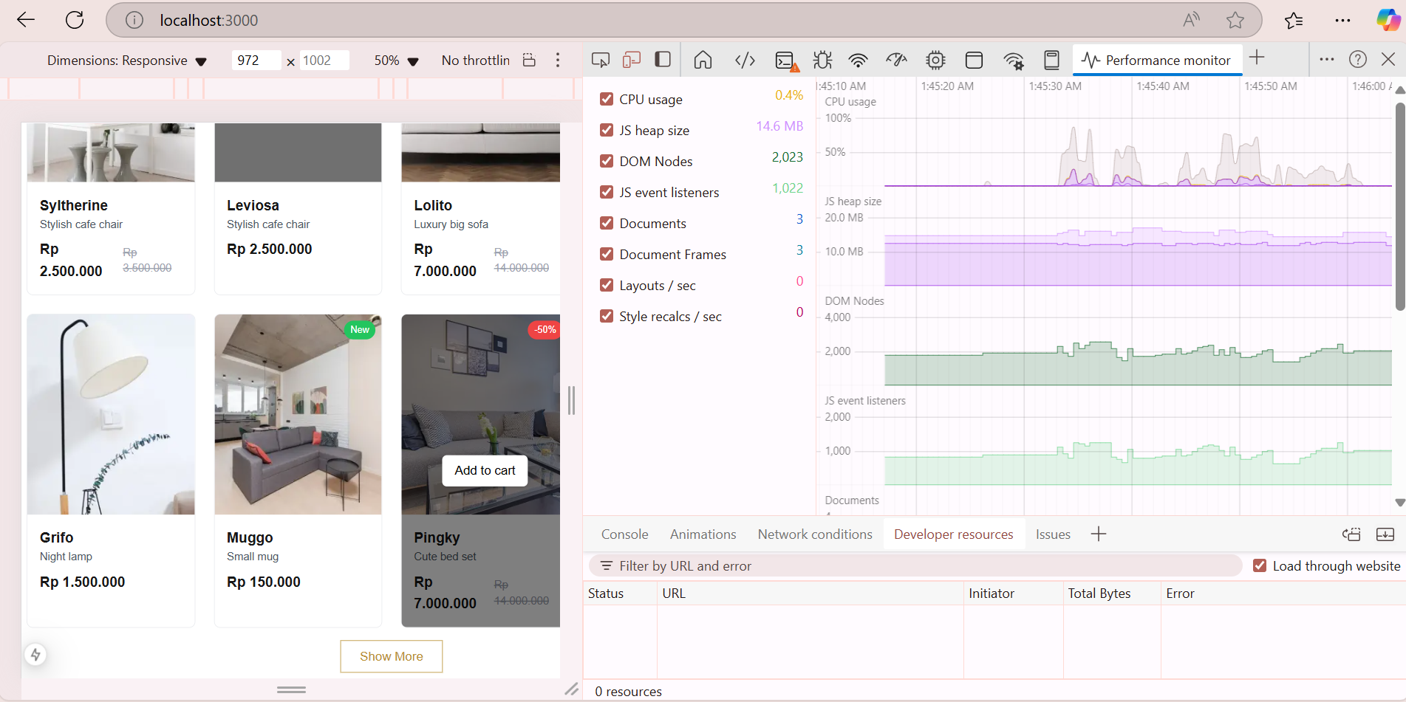

**Developer resources**

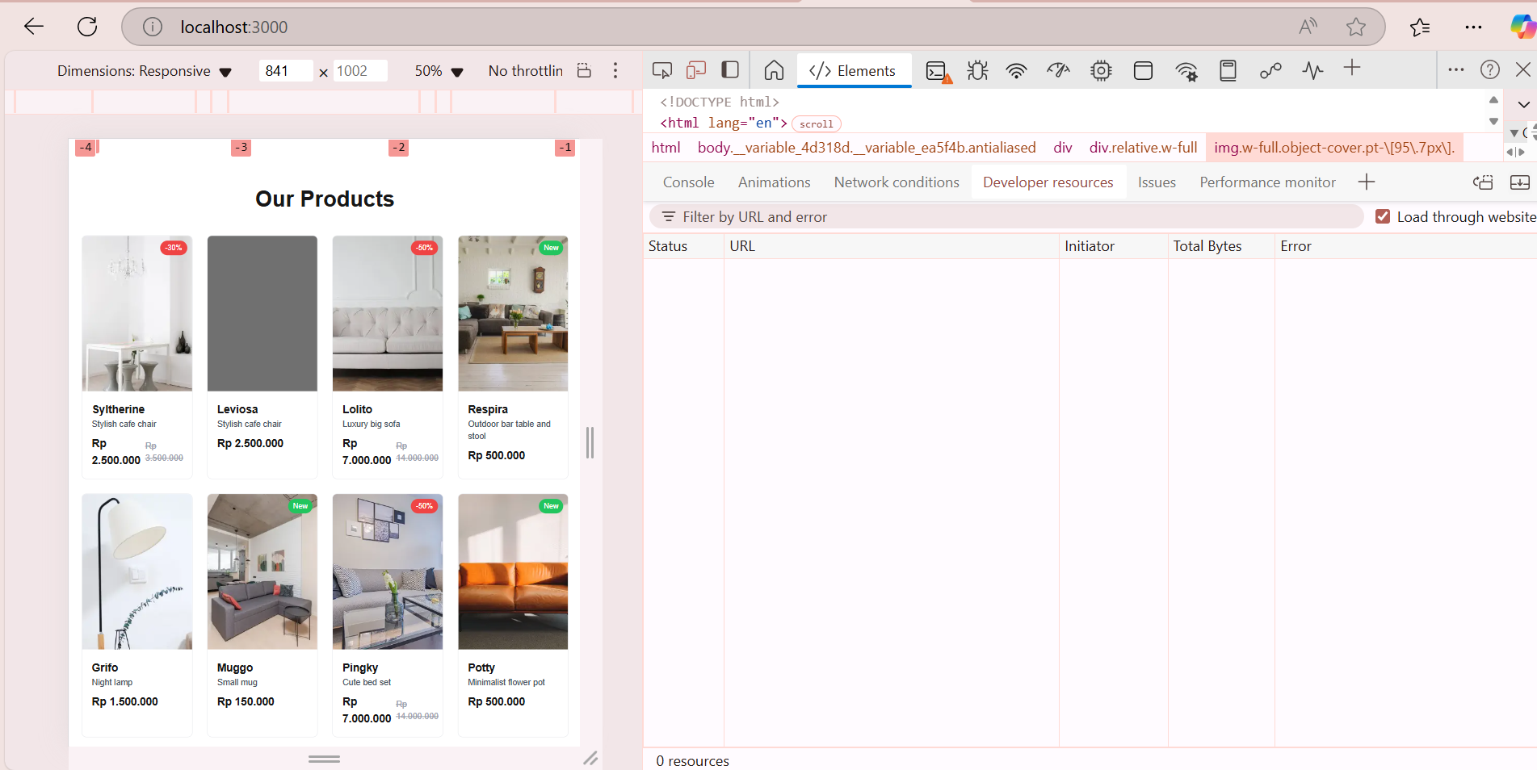

**Security overview**

